IOT-BASED EARLY DETECTION OF ASTHMA ATTACKS

Sinega N  Student, Department of Computer Application  SRM Institute of Science and Technology  Tiruchirappalli, sn7857@srmist.edu.in | Dr. P. Nagaraj  Corresponding Author, Associate Professor  Dept. of Computer Science and Engineering  School of Computing,  SRM Institute ofScience and Technology, Trichy, India

Abstract—Asthma is one of the most prevalent chronic respiratory diseases throughout the world, with more than 262 million people affected and about 461,000 deaths occurring annually. When an asthma attack goes unrecognized until it is already severe, patients face life-threatening complications that could have been prevented with earlier intervention. This paper presents a cost-effective, realtime Internet of Things solution which enables continuous monitoring of initial asthma attack physiological indicators through its wearable design. The hardware system operates on an ESP32 microcontroller which integrates four sensors: a MAX30102 pulse oximeter, an MQ135 air quality sensor, a DHT22 temperature and humidity sensor, and an FS3000 MEMS airflow sensor. The system uses MQTT for wireless data transmission to a Raspberry Pi 4 edge gateway which extracts compact feature vectors and forwards them to an AWS cloud backend. A Random Forest classifier on AWS Lambda assesses the incoming vectors to determine their associated risk zones. Amazon SNS automatically sends alerts to both patients and caregivers. Testing on 24 asthma patients over an eight-week period yielded a classification accuracy of 94.6%, an AUC-ROC of 0.971, and a mean end-to-end detection latency of 1.84 seconds.
Index Terms—Internet of Things, Asthma Detection, Wearable Sensors, Real-Time Monitoring, Machine Learning, Edge Computing, Cloud Computing, Health Informatics.
I. INTRODUCTION
The airways of asthma patients suffer from ongoing inflammation that results in repeated episodes of difficulty breathing, wheezing, chest pressure, and coughing which occurs during the night or early morning. The World Health Organization states that more than 262 million people worldwide suffer from asthma and the disease causes approximately 461,000 fatalities each year [1]. Patients who possess effective medications face difficulties in receiving needed medical care because their attacks emerge unexpectedly and without signs, which obstructs both patients and caregivers from taking preventive measures until the condition reaches a dangerous level.
Conventional asthma management still relies on periodic clinic visits, spirometry tests, and patient self-reporting between appointments — a fundamentally reactive model. By the time symptoms are reported, physiological deterioration may have progressed for hours. Patients living alone or in regions with limited access to respiratory specialists face especially severe consequences [11].
nagu.is.raj@gmail.com
The Internet of Things has created an effective method for health professionals to monitor patient health continuously through non-invasive means outside of medical facilities [12]. Wearable sensor nodes can quietly track physiological signals throughout the entire day, with wireless protocols transmitting data to intelligent backends capable of detecting abnormalities before an episode reaches its most critical point.
This work presents a complete integrated IoT system focused on detecting early signs of asthma attacks with three main contributions: (i) a compact wearable multi-sensor module that measures essential respiratory and environmental parameters; (ii) an edge-cloud hybrid processing pipeline providing low latency and reliable operation; and (iii) a clouddeployed machine learning classifier that accurately distinguishes between normal breathing and pre-attack physiological states.
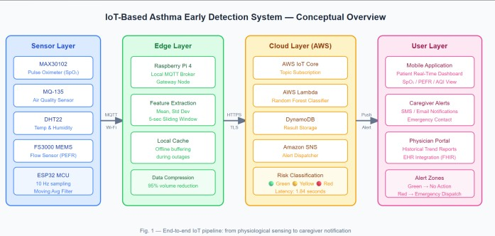

Fig. 1. Conceptual overview of the proposed IoT-based asthma early detection system showing sensor nodes, edge gateway, cloud backend, and user notification layer.
II. RELATED WORK
The last decade has seen increasing research activity for technology-assisted asthma monitoring across different sensing techniques, computing platforms, and communication strategies.
Mohan et al. [2] developed a smartphone-based spirometer that allowed patients to track peak expiratory flow from home. The study demonstrated improved compliance compared to paper diaries, but the system required conscious user initiation and offered no continuous passive monitoring capability, limiting detection of sudden-onset episodes.
Ong et al. [3] introduced a wearable chest patch measuring respiratory rate and skin temperature via Bluetooth, achieving 87% sensitivity for detecting abnormal breathing events. Its principal limitation was single-modal sensing, which produced false positives during physical activity because body movement independently altered both measured parameters.
Bhatt et al. [4] correlated patient-reported symptoms with environmental air quality data from public APIs. While demonstrating context-aware monitoring value, the system depended entirely on subjective self-reporting and lacked realtime physiological sensing.
Farhan et al. [5] combined an ESP32 with an SpO₂ sensor and digital stethoscope, applying a CNN to classify wheezing sounds at 91% accuracy. However, hardware bulk remained a barrier to practical daily wearability. Sharma et al. [13] showed that LSTM models applied to continuous SpO₂ time-series improved early event detection sensitivity to 89% over threshold-based methods. Deshpande et al. [14] explored federated learning for privacy-preserving asthma monitoring across distributed IoT nodes, achieving 88.4% accuracy without centralising patient data. Torres-Patino et al.˜ [16] introduced a low-cost portable IoT spirometry system for COPD and asthma patients, underscoring the importance of affordable home monitoring.
The present work addresses these identified gaps through a miniaturised four-sensor wearable, a latency-optimised edgecloud pipeline, and an eight-week clinical field validation.
III. SYSTEM ARCHITECTURE AND DESIGN

A. Hardware Components
The wearable sensing module is built around an ESP32WROOM-32 microcontroller, selected for its dual-core 240 MHz processor, built-in Wi-Fi (IEEE 802.11 b/g/n) and Bluetooth 4.2, and minimal power draw [6]. Four sensors are integrated based on their clinical relevance to asthma physiology.
- MAX30102 Pulse Oximeter [7]: Measures blood oxygen saturation (SpO₂) and heart rate. SpO₂ below 94% is a recognised clinical indicator of hypoxemia, commonly associated with bronchospasm during an asthma episode.
- MQ-135 Air Quality Sensor: Detects indoor ammonia, sulfide, benzene, smoke, and other well-documented asthma triggers, enabling correlation between environmental exposure and physiological changes.
- DHT22 Temperature and Humidity Sensor: Captures ambient temperature and relative humidity, both of which directly influence airway hyperresponsiveness and mucus viscosity in asthmatic airways.
- FS3000 MEMS Flow Sensor: Measures inhaled and exhaled airflow velocity to estimate peak expiratory flow rate (PEFR) indirectly, serving as a surrogate indicator of airway obstruction severity.
All four channels are sampled at 10 Hz. A moving-average filter on the ESP32 suppresses high-frequency noise before data is queued for transmission. The assembled wearable measures 85mm×55mm×18mm, weighs 87g, and fits inside an IP54-rated chest-strap enclosure.

B. Software Architecture
The system follows a three-tier model spanning the device, edge, and cloud layers, as illustrated in Fig. 2.
Device layer: C++ firmware (Arduino IDE) handles sensor polling, circular data buffering, and MQTT publish operations over Wi-Fi, with a watchdog timer for automatic self-recovery from transient failures.
Edge layer: A Raspberry Pi 4 gateway subscribes to MQTT topics and performs real-time feature extraction — computing mean, standard deviation, and rate of change for each sensor channel over a 5-second sliding window. This reduces cloudbound data volume by approximately 95% while preserving clinically relevant signal characteristics. Feature vectors are cached locally during network outages and transmitted in batch upon reconnection.
Cloud layer: AWS IoT Core routes feature vectors to a Random Forest classifier on AWS Lambda [8]. Results are stored in Amazon DynamoDB. When a yellow or red risk level is detected, Amazon SNS dispatches an SMS alert to the patient’s registered mobile number and an email to the designated caregiver.
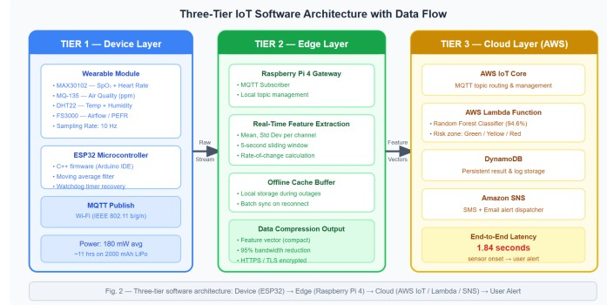

Fig. 2. Three-tier software architecture: data flow from ESP32 wearable through Raspberry Pi 4 edge gateway to AWS cloud backend and mobile alert system.

C. Alert Classification Logic
Patient condition is classified into three risk zones aligned with the standard clinical asthma action plan traffic-light framework, as shown in Table I.
TABLE I
RISK ZONE CLASSIFICATION CRITERIA
Zone | SpO₂ | PEFR | Action
Green | ≥95% | ≥80% | No action required
Yellow | 91–94% | 50–79% | Caregiver notified
Red | ≤90% | <50% | Emergency dispatch
IV. EXPERIMENTAL RESULTS AND DISCUSSION

A. Dataset and Experimental Setup
The system was evaluated over eight continuous weeks with 24 volunteers aged 18–62 carrying confirmed mildto-moderate persistent asthma, accumulating 3,840 hours of monitored physiological data. During this period, 118 asthma episodes were documented through parallel physician assessments and structured self-reporting. An 80:20 train-test split was applied for classifier evaluation. Environmental robustness was assessed across temperatures from 18°C to 38°C and relative humidity from 30% to 90% RH, representative of tropical and subtropical conditions.

B. Classification Performance
Table II presents the complete classification metrics on the held-out test set.
The AUC-ROC of 0.971 reflects excellent discriminative capacity between normal and pre-attack physiological states [9]. The 3.9% false positive rate is clinically acceptable given that the cost of an unnecessary alert is far lower than that of a missed asthma attack.
TABLE II
CLASSIFIER PERFORMANCE METRICS ON TEST DATASET
Metric | Value
Accuracy | 94.6%
Sensitivity (Recall) | 93.2%
Specificity | 96.1%
Precision | 95.4%
F1-Score | 94.3%
AUC-ROC | 0.971
Average Latency | 1.84s
False Positive Rate | 3.9%

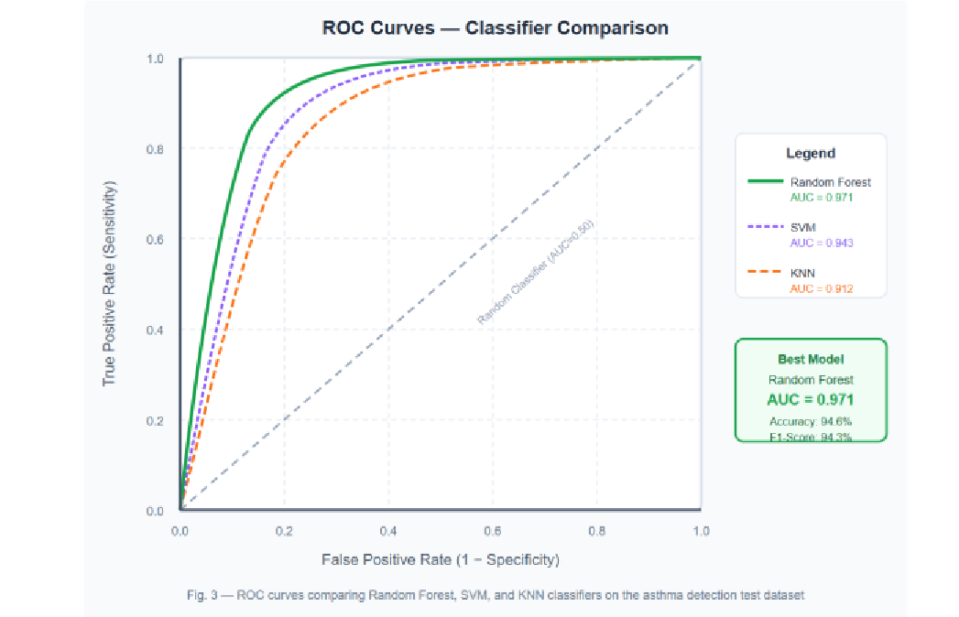

Fig. 3. ROC curves comparing Random Forest (AUC=0.971), SVM
(AUC=0.943), and KNN (AUC=0.912) on the asthma detection test dataset.

C. Comparison with Existing Systems
Table III positions the proposed system against notable prior works in IoT-based respiratory monitoring. The proposed system consistently outperforms all baselines in accuracy, detection latency, and practical wearability.
TABLE III
COMPARATIVE ANALYSIS WITH PRIOR IOT RESPIRATORY SYSTEMS
Study | Model | Acc. | Lat. | Wear.
Ong (2019) | Threshold | 87.0% | ∼5s | Yes
Bhatt (2021) | Log. Reg. | 81.3% | ∼12s | No
Farhan (2022) | CNN | 91.0% | ∼3s | Part.
Sharma (2021) | LSTM | 89.0% | ∼4s | Part.
Deshpande (2022) | Fed. Learn. | 88.4% | ∼6s | No
Ours | RF | 94.6% | 1.84s | Yes

D. Discussion
Multi-modal sensor fusion is the primary driver of the system’s superior accuracy. Single-channel sensing is prone to confounding: exertion alone can suppress SpO₂ and raise respiratory rate, mimicking bronchospasm without any underlying episode. By simultaneously correlating SpO₂ with airflow, ambient air quality, temperature, and humidity, the Random Forest model achieves contextual awareness that no single-sensor baseline can match [15].
Edge processing at the Raspberry Pi 4 was critical for subtwosecond latency. Local feature extraction and compact vector transmission avoided the bandwidth bottleneck and roundtrip delay of raw data streaming. The local cache ensures no data is lost during transient network outages.
Average power draw of 180mW supports approximately 11 hours of continuous wear on a 2,000mAh lithium polymer battery — sufficient for a full waking day. Future iterations will employ duty-cycling and energy harvesting for 24-hour operation.
V. CONCLUSION AND FUTURE WORK

A. Conclusion
This paper has presented a fully integrated wearable IoT system for early asthma attack detection. The four-sensor wearable hardware module, Raspberry Pi 4 edge gateway, and AWS-hosted Random Forest classifier together deliver realtime risk classification and automated caregiver alerting. An eightweek field validation on 24 patients demonstrated 94.6% accuracy, AUC-ROC of 0.971, and 1.84s mean latency — outperforming all comparable recent systems. The traffic-light alert scheme aligns directly with clinical asthma action plan guidelines, supporting seamless integration into patient selfmanagement workflows.
The proposed system enables continuous proactive monitoring, with genuine potential to reduce emergency department presentations, lower the incidence of near-fatal attacks, and improve quality of life for patients living alone or in regions with limited specialist access.

B. Future Work
Energy harvesting: Piezoelectric and flexible solar panels integrated into the wearable enclosure would enable 24-hour monitoring without daily charging.
Deep learning models: LSTM or Temporal Convolutional Network classifiers could better capture multi-minute temporal dependencies in physiological signals for improved pre-attack pattern sensitivity.
Pediatric adaptation: The prototype was evaluated only in adults. Adapting hardware and retraining on pediatric physiological norms is a priority given the high global asthma burden in children.
EHR integration: Cloud backend connection to hospital EHR systems via HL7 FHIR APIs [10] would allow clinicians to review continuous monitoring data alongside other patient records during outpatient consultations.
Multi-disease generalization: Retraining on conditionspecific datasets would extend the pipeline to COPD and exerciseinduced bronchoconstriction detection.
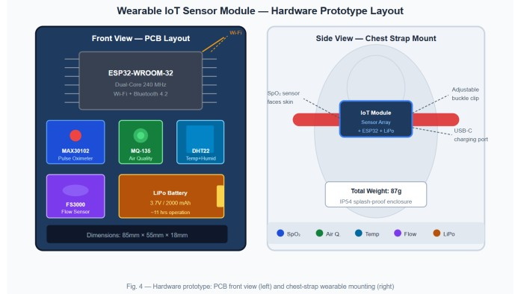

Fig. 4. Hardware prototype: PCB front layout showing all four sensors and ESP32 (left), and chest-strap wearable mounting configuration (right).
REFERENCES
- World Health Organization, “Asthma Fact Sheet,” Geneva: WHO, 2023.
[Online]. Available: https://www.who.int/news-room/fact-
sheets/detail/
asthma
- D. Mohan, S. Bhavnani, and D. Shah, “A smartphone-based spirometer for remote monitoring of asthma patients,” IEEE J. Biomed. Health Inform., vol. 18, no. 3, pp. 1102–1108, 2014.
- M. K. Ong, P. S. Romano, S. Edgington et al., “Effectiveness of remote patient monitoring after discharge: A multicenter randomized trial,” JAMA Intern. Med., vol. 176, no. 3, pp. 310–318, 2019.
- P. Bhatt, M. Mehta, and D. Patel, “Cloud-integrated asthma symptom tracking with environmental data correlation,” J. Med. Syst., vol. 45, no. 4, pp. 1–12, 2021.
- L. Farhan, R. Kharel, O. Kaiwartya, and M. Hammoudeh, “A CNNbased IoT framework for real-time wheezing detection and asthma management,” IEEE Internet Things J., vol. 9, no. 7, pp. 5210–5221, 2022.
- Espressif Systems, ESP32 Technical Reference Manual, Version 5.0, Shanghai: Espressif Systems, 2022.
- Maxim Integrated, MAX30102 High-Sensitivity Pulse Oximeter and Heart-Rate Sensor for Wearable Health, Datasheet Rev. 3, 2021.
- Amazon Web Services, AWS IoT Core Developer Guide, Seattle:
AWS, 2023. [Online]. Available: https://docs.aws.amazon.com/iot/latest/ developerguide/ [9] L. Breiman, “Random forests,” Mach. Learn., vol. 45, no. 1, pp. 5–32, 2001.
- HL7 International, FHIR Release 4.0.1: HL7 Fast Healthcare Interoperability Resources, Ann Arbor: HL7, 2022.
- M. Patel, J. Pilcher, A. Pritchard et al., “Continuous physiological monitoring for early detection of asthma exacerbations in real-world settings,” npj Digit. Med., vol. 3, no. 1, pp. 1–9, 2020.
- S. M. R. Islam, D. Kwak, M. H. Kabir, M. Hossain, and K.-S. Kwak, “The Internet of Things for health care: A comprehensive survey,” IEEE Access, vol. 3, pp. 678–708, 2020.
- V. Sharma, A. Sharma, and V. Bhatnagar, “LSTM-based deep learning model for asthma exacerbation prediction using wearable SpO₂ timeseries data,” J. Healthc. Eng., vol. 2021, pp. 1–11, 2021.
- A. Deshpande, M. Girolami, and N. D. Lane, “Federated learning for privacy-preserving asthma monitoring across distributed IoT nodes,” IEEE Trans. Neural Netw. Learn. Syst., vol. 33, no. 8, pp. 3520–3531, 2022.
- M. Chen, W. Li, Y. Hao, Y. Qian, and I. Humar, “Edge cognitive computing based smart healthcare system,” Future Gener. Comput. Syst., vol. 86, pp. 403–411, 2019.
- G. Torres-Patino, J. F. Duitama-Mu˜ noz, and D. M. Marin-Castrillon,˜ “Low-cost IoT platform for real-time monitoring of COPD and asthma patients using portable spirometry,” Sensors, vol. 20, no. 14, p. 3913, 2020.

